Student ID: 2400090136
Name: MADDA.HARSHAVARDHAN REDDY
Skill Experiment Number: Skill-11
Section Number: 56

TITLE: React API Integration - Fetching Data Using Fetch API, Axios & Local JSON
CODE:
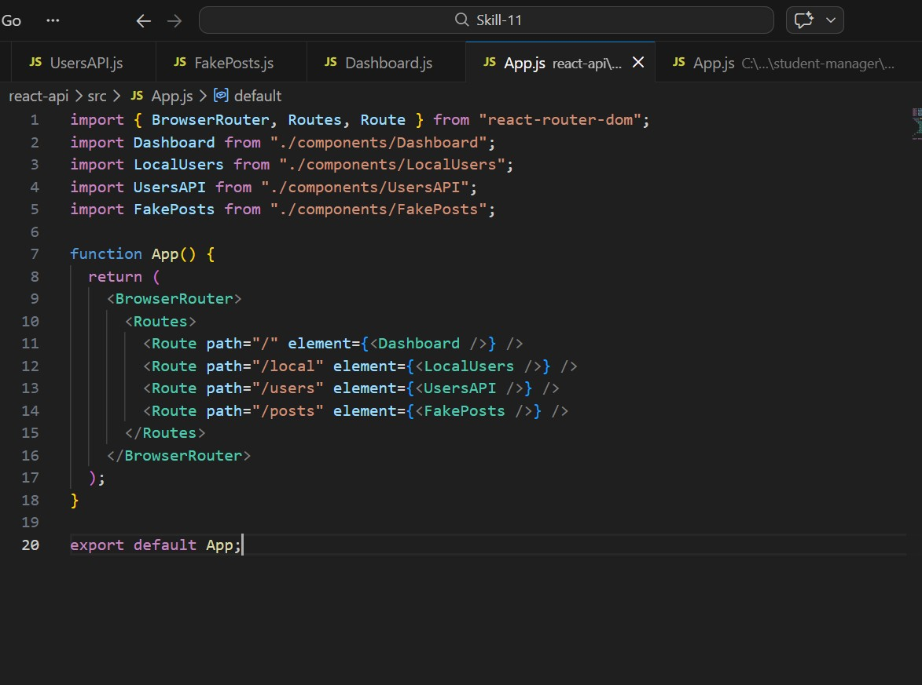
OUTPUT:
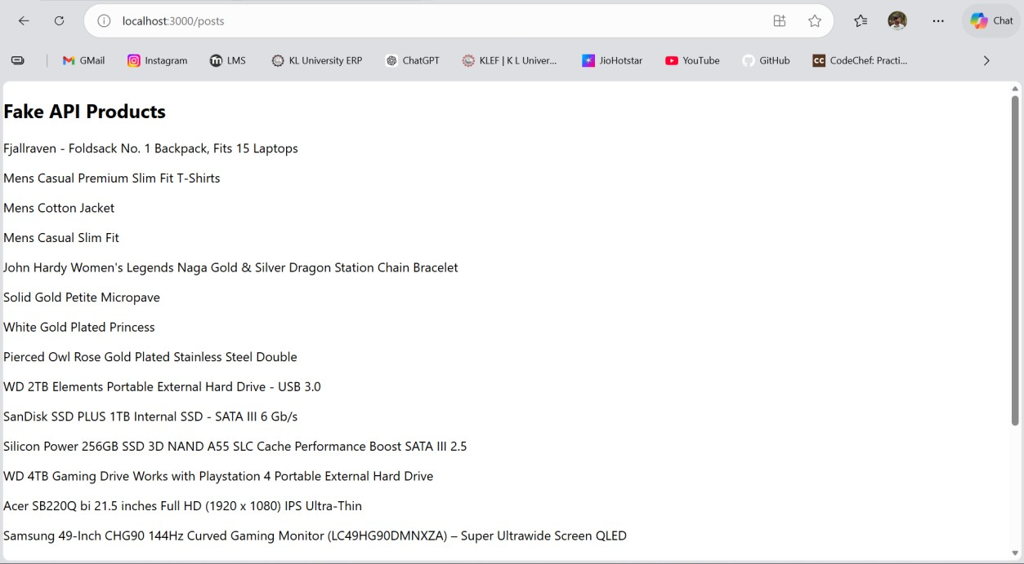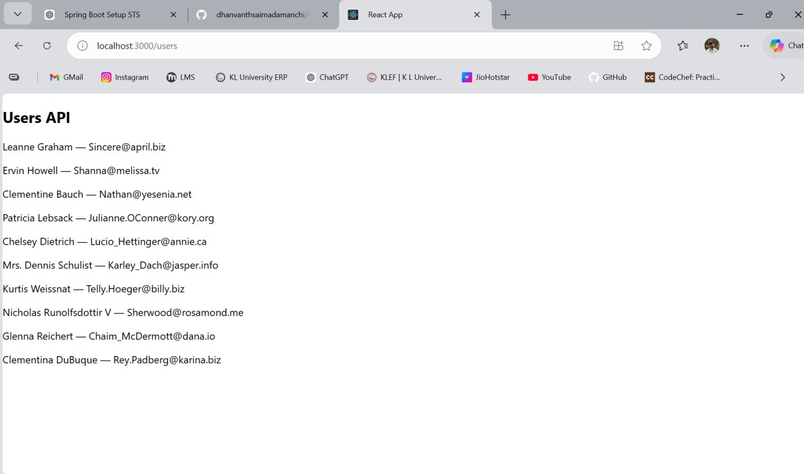
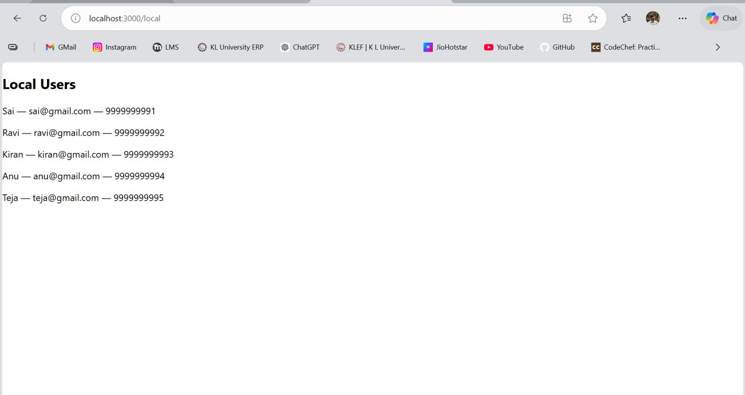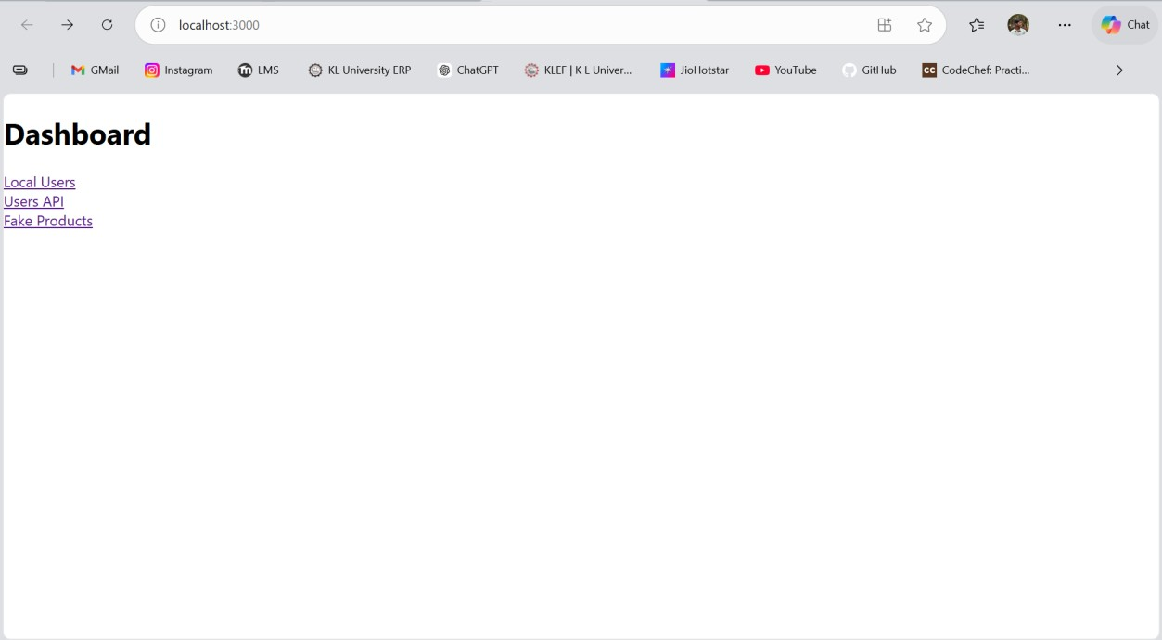
GitHub Repository Link: dhanvanthsaimadamanchi/SKill-11

